Topic of the project:

Project name: "ASIC design with open source tools"

Developing of an low resolution ADC. As example an 4-Bit ADC with conversion of the thermometer code into binary code.

Steps:  
A small CMOS inverter with xschem and the sky130a technology (PDK) and simulate the circuit with ngspice:

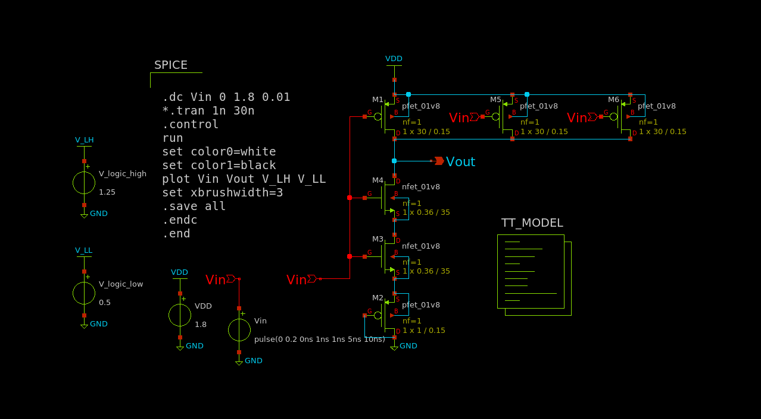

The above figure is the schematic for 15th threshold point of the analogue part of the ADC. The plot is as follows:

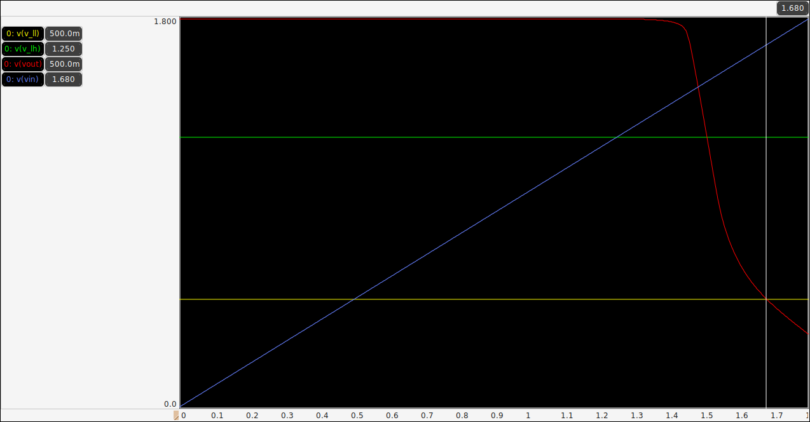

The inverter will switch from logic-high or undefined to logic-zero when input voltage exceeds 1.68 volts. So, for this inverter the threshold is 1.68 volts.

For a 4-bit ADC we need 16 voltage level including zero (0~1.68 volts). The quantization should be 1.68/16=0.112 volts.

**Vdd = 1.8 V**

Th. 0: 0

Th. 1: 0.112

Th. 2: 0.224

Th. 3: 0.336

Th. 4: 0.448

Th. 5: 0.56

Th. 6: 0.672

Th. 7: 0.784

Th. 8: 0.896

Th. 9: 1.008

Th. 10: 1.12

Th. 11: 1.232

Th. 12: 1.344

Th. 13: 1.456

Th. 14: 1.568

Th. 15: 1.680

**Binary Logic level assumption**

<https://en.wikipedia.org/wiki/Logic_level>

|  |  |  |  |
| --- | --- | --- | --- |
| Technology | L Voltage | H Voltage | note |
| CMOS | 0 to 30% of Vdd | 70% of Vdd to Vdd | Vdd = Supply voltage |
|  | ≈0.5 Volt | ≈1.25 Volts | Vdd = 1.8 Volts |

Magic=>before importing netlist to ngspice check LVS net

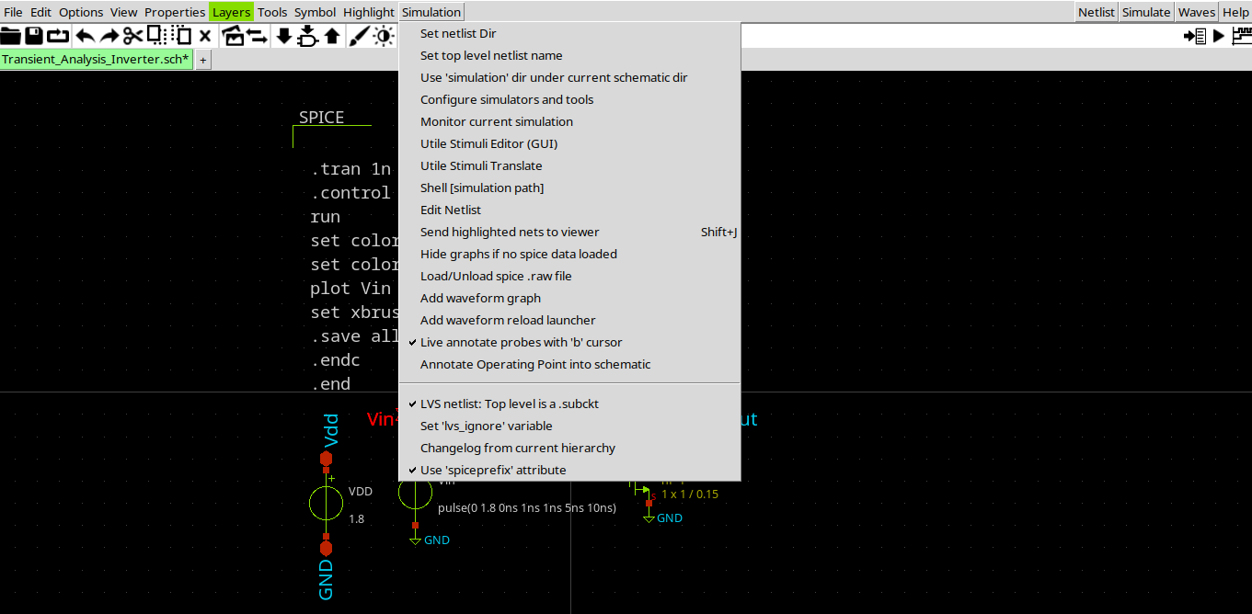

<http://web02.gonzaga.edu/faculty/talarico/vlsi/xschemTut.html>

<https://ngspice.sourceforge.io/ngspice-control-language-tutorial.html>

**Alter subckt tutorial**—

<https://sourceforge.net/p/ngspice/discussion/133842/thread/5ad086c79f>

<https://sourceforge.net/p/ngspice/discussion/133842/thread/9a75acf2/#bf90/45b3/ea48>

**Pyspice ngspice interpreter**

https://pyspice.fabrice-salvaire.fr/releases/v1.3/examples/ngspice-shared/ngspice-interpreter.html

https://github.com/ashwith/ngspicepy

**Read spice raw output data**

https://gist.githubusercontent.com/snmishra/27dcc624b639c2626137/raw/742fe0dd59c7b2c41b71a1c8c1c2506d13affc53/rawread.py

**ngspice wrapper for python**

https://github.com/eps82/lyngspice/wiki

- write some verilog code to convert the thermometer code (from the inverter stages) into the binary code

<http://www.asic-world.com/verilog/veritut.html>

<https://www.youtube.com/playlist?list=PLfGJEQLQIDBN0VsXQ68_FEYyqcym8CTDN>

<https://github.com/Swagatika-Meher/msvsd2bitcomp>

<https://www.youtube.com/playlist?list=PLvXKBnlvcSm30Y0zu1765oG_x-ECU8tVG>

<https://learning.edx.org/course/course-v1:HarveyMuddX+ENGR85A+3T2021/home>

<https://www.vlsiuniverse.com/digital-thermometer-code-in-verilog-vhdl-flash-adc-binary-encoder/>

<https://www.classcentral.com/subject/vlsi?free=true>

<https://www.eng.biu.ac.il/temanad/digital-vlsi-design/>

<https://www.youtube.com/playlist?list=PLZU5hLL_713x0_AV_rVbay0pWmED7992G>

<https://youtu.be/BIqLk23hE90?list=PLZU5hLL_713x0_AV_rVbay0pWmED7992G>

- get familiar with the yosis syntesis tool to convert the verilog code into a CMOS circuit  
- simulate the complete (ultra small) ADC

References:

<https://github.com/bluecmd/learn-sky130/blob/main/schematic/xschem/getting-started.md>

* What is Schematic Capture and why do we need it?
* What is a process?

**-----------------**

**Run iverilo/icarus**

iverilog file.v

vvp a.out

---------------------------

**Vdd = 5 Volt**

Vsat_max = 4.616

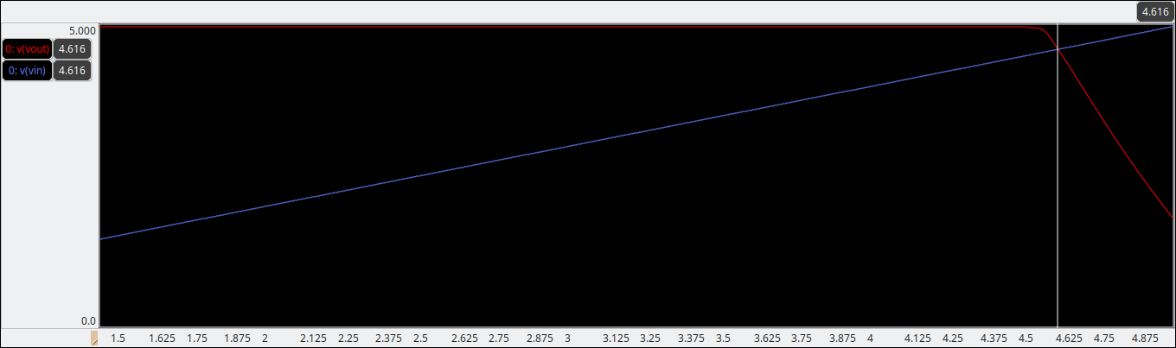

Vsat_min = 481.3mV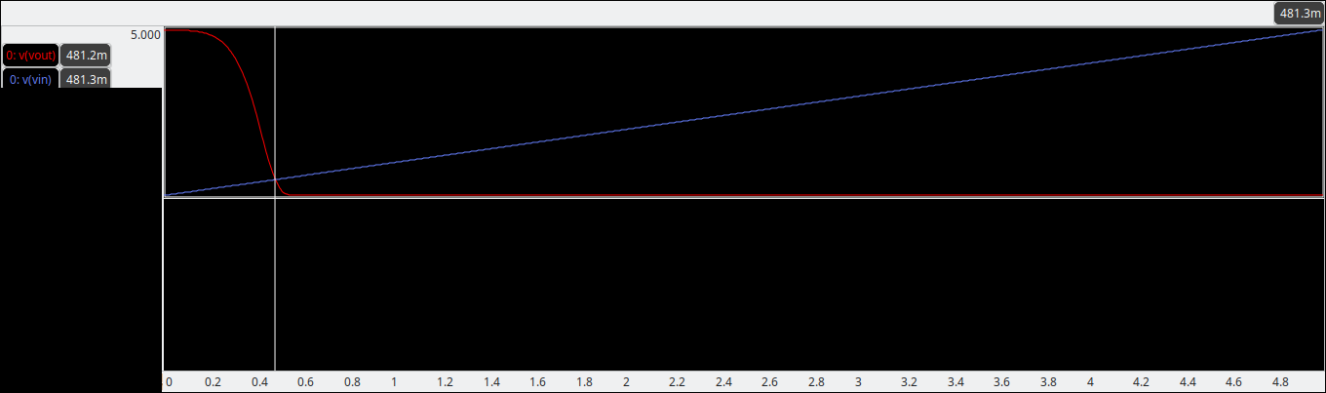

Voltage range = 4.616 – 0.4813 = 4.1347 V

Step voltage = 4.1347/15 = 0.275647

Set. 1: 0.4813

Set. 2: 0.756947

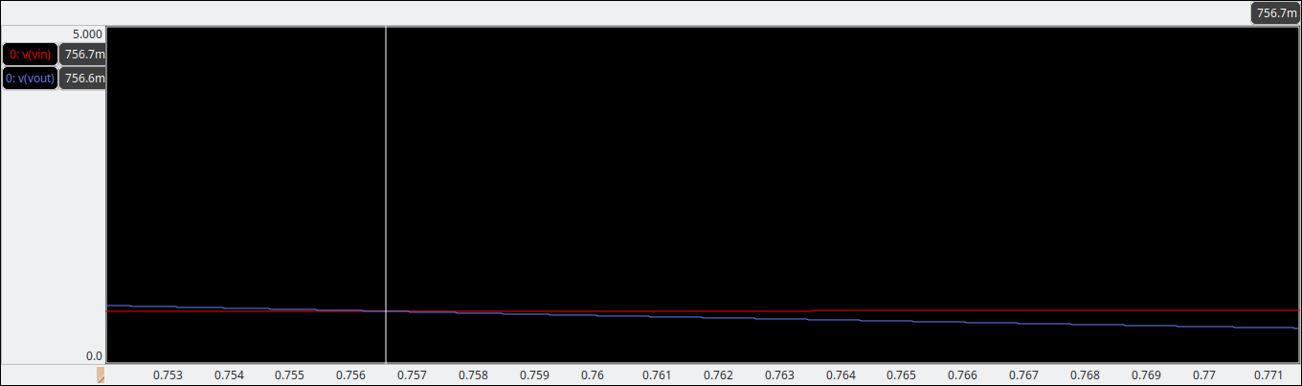

Set. 3: 1.032594

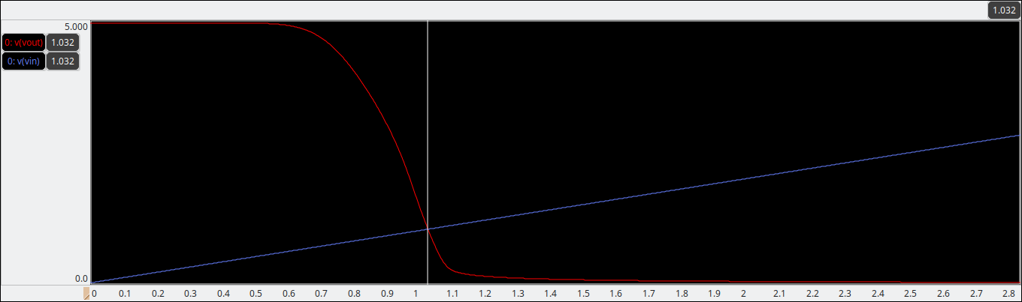

Set. 4: 1.308241

Set. 5: 1.583888

Set. 6: 1.859535

Set. 7: 2.135182

Set. 8: 2.410829

Set. 9: 2.686476

Set. 10: 2.96212

Set. 11: 3.23777

Set. 12: 3.513417

Set. 13: 3.789064

Set. 14: 4.064711

Set. 15: 4.340358

Set. 16: 4.616005